ATAC-seq Protocol
Kaestner Lab

Reagents
1X PBS
Nuclease-free H₂O
NP-40 10%
Nextera DNA Library Prep Kit (Illumina, catalog # FC-121-1030)
MinElute Reaction Cleanup Kit (Qiagen, catalog # 28204)
Primers (see table at end of protocol)
NEBNext High-Fidelity 2X PCR Master Mix (NEB, catalog # M0541S)
SYBR Green I (ThermoFisher, catalog # S7563)
Agencourt AMPure XP magnetic beads (Beckman Coulter, catalog # A63880)
80% Ethanol (made fresh)
Agilent High Sensitivity DNA Bioanalysis Kit (Agilent, catalog # 5067-4626)
Qubit dsDNA HS Assay Kit & fluorometer (ThermoFisher, catalog # Q32851)

Notes
- The primary protocol is based on the Buenrostro et al. papers, with the following modification:
- We found that column purification of the libraries does not remove primer-dimers (78 bp), and our libraries often contained large fragments 1,000-10,000 bp in length. Therefore, we use magnetic bead purification rather than column purification of the libraries. We recommend that you perform bioanalysis of your initial libraries to determine whether double-sided bead purification is needed.
- Typically, 50,000-100,000 cells yield the best results. As few as 5,000 have been reported to work. The ratio of transposase to cell number is important. We recommend that, if possible, you test different cell numbers and different transposase:cell ratios. The Buenrostro et al. papers are based on using 50,000 cells. We typically use 100,000 cells and double the volume of all reagents in the protocol.
- Cells must be alive, fresh, not frozen. Pipet and centrifuge gently to avoid damaging/lysing cells prior to the cell lysis step.

Cell Lysis
- Wash 50,000 cells with 50 μl cold 1X PBS in epi tube, centrifuge to pellet, discard supernatant.
- Add 50 μl cold lysis buffer, pipet up and down to resuspend cells.
10 μl 1M Tris·Cl, pH 7.4 (final 10 mM)
2 μl 5 M NaCl (final 10 mM)
3 μl 1 M MgCl₂ (final 3 mM)
10 μl 10% NP-40 (final 0.1% v/v)
975 μl nuclease-free H₂O
1,000 μl
- Centrifuge at 500 xg for 10 minutes at 4ºC.
- Discard supernatant (cytoplasm), keep pellet (nuclei).

Transposition
- While cells are centrifuging, make transposition reaction mix, using the Nextera DNA Library Prep Kit. Volumes per sample of 50,000 cells:
25 μl 2X TD Buffer
2.5 μl Tn5 Transposase
22.5 μl nuclease-free H₂O
50 μl
- Add transposition reaction mix to pellet, pipet up and down to resuspend nuclei.
- Incubate at 37ºC for 30 minutes.

DNA Purification
- Isolate DNA using Qiagen MinElute Reaction Cleanup Kit.
- Elute DNA in 10 μl EB (Elution Buffer).

**OK to store DNA at -20ºC at this point.

PCR Amplification (Library Generation)
- Combine the following in a PCR tube for each sample:
10 μl purified transposed DNA
10 μl nuclease-free H₂O
2.5 μl Ad1_noMX primer (25 μM)
2.5 μl Ad2.* indexing primer (25 μM)
25 μl NEBNext High-Fidelity 2X PCR Master Mix
50 μl
- Amplify samples in PCR machine with following program:
72ºC 5 minutes
98ºC 30 seconds
98ºC 10 seconds
63ºC 30 seconds x5 cycles
72ºC 1 minute
- Remove tubes from PCR machine and use 5 μl of each partially-amplified library to perform qPCR to determine how many additional PCR cycles are needed. The goal is to stop amplification well prior to saturation to avoid variation among samples due to PCR bias.
5 μl partially-amplified library
4.41 μl nuclease-free H₂O
0.25 μl Ad1_noMX primer (25 μM)
0.25 μl Ad2.* indexing primer (25 μM)
0.09 μl 100X SYBR Green I
5 μl NEBNext High-Fidelity 2X PCR Master Mix
15 μl
- Perform qPCR using following program:
98ºC 30 seconds
98ºC 10 seconds
63ºC 30 seconds x20 cycles
72ºC 1 minute
- Plot R vs Cycle Number. Calculate the number of additional PCR cycles needed for each sample, by determining the number of cycles needed to reach 1/3 of the maximum R.
- Continue PCR on remaining 45 μl of each partially-amplified library for the appropriate number (N) of cycles:
98ºC 30 seconds
98ºC 10 seconds
63ºC 30 seconds N cycles
72ºC 1 minute

Library Purification:
- Warm AMPure XP beads to room temperature, and vortex to resuspend.
- For single left-sided bead purification (to remove primer dimers):
- Transfer each PCR sample to an epi tube, add 1.8X volume (81 μl) AMPure XP beads, pipet up and down 10x to mix thoroughly.
- Incubate at room temperature for 10 minutes.
- Place epi tubes in magnetic rack for 5 minutes.
- Discard supernatant.
- Wash beads with 200 μl 80% EtOH (freshly made), pipet EtOH over beads 10x, then discard EtOH.
- Leave tube on magnetic rack with cap open for 10 minutes.
- Ensure all EtOH is removed.
- Resuspend beads in 20 μl nuclease-free H₂O, pipet up and down 10x to mix thoroughly.
- Place epi tube in magnetic rack for 1-5 minutes.
- Transfer supernatant to new epi tube.
- For double-sided bead purification (to remove primer dimers and large >1,000 bp fragments):
- Transfer each PCR sample to an epi tube, add 0.5X volume (22.5 μl) AMPure XP beads, pipet up and down 10x to mix thoroughly.
- Incubate at room temperature for 10 minutes.
- Place epi tubes in magnetic rack for 5 minutes.
- Transfer supernatant to new epi tube.
- Add 1.3X original volume (58.5 μl) AMPure XP beads, pipet up and down 10x to mix thoroughly. (This results in a final 1.8X bead buffer:sample ratio.)
- Incubate at room temperature for 10 minutes.
- Place epi tubes in magnetic rack for 5 minutes.
- Discard supernatant.
- Wash beads with 200 μl 80% EtOH (freshly made), pipet EtOH over beads 10x, then discard EtOH.
- Leave tube on magnetic rack with cap open for 10 minutes.
- Ensure all EtOH is removed.
- Resuspend beads in 20 μl nuclease-free H₂O, pipet up and down 10x to mix thoroughly.
- Place epi tube in magnetic rack for 1-5 minutes.
- Transfer supernatant to new epi tube.
- Store purified libraries at -20ºC.

Assessing Library Quality:
- Add 1 μl of each library to 3 μl nuclease-free H₂O (to make 1:4 dilution).
- Run 1 μl of each diluted library on an Agilent High Sensitivity DNA Bioanalysis chip.
- Use 1 μl of each diluted library to measure DNA concentration by QuBit.

Sequencing:
- Use 50 bp paired-end (50PE) sequencing.
- Goal is to obtain >50 million reads per sample minimum to assess open vs closed chromatin regions, and >200 million reads per sample to detect transcription factor binding sites. Remember that many sequencing reads may map to contaminating mitochondrial DNA.

Table of PCR Primers (based on TruSeq indices):
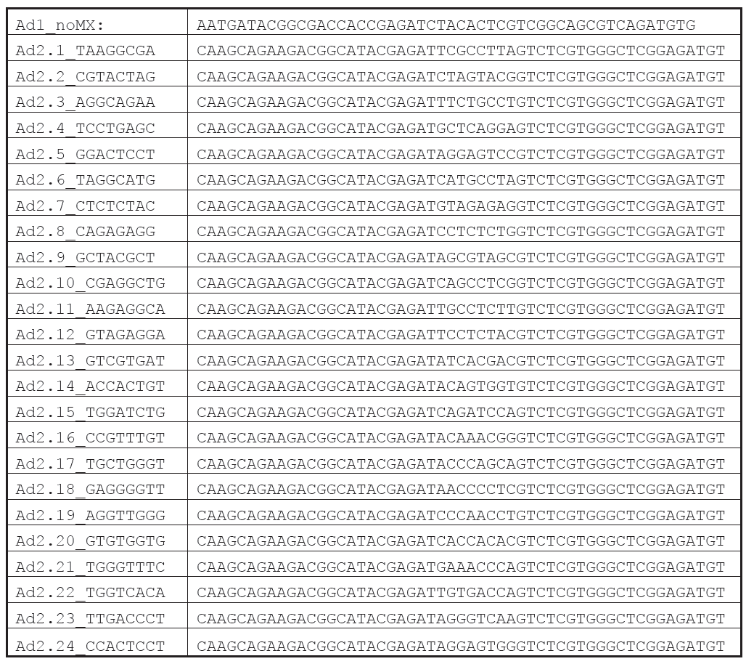

References:
[1] Ackermann AM, Wang Z, Schug J, Naji A, Kaestner KH (2016) Integration of ATAC-seq and RNA-seq identifies human alpha cell and beta cell signature genes. Molecular Metabolism 5: 233-244
[2] Buenrostro JD, Giresi PG, Zaba LC, Chang HY, Greenleaf WJ (2013) Transposition of native chromatin for fast and sensitive epigenomic profiling of open chromatin, DNA-binding proteins and nucleosome position. Nature methods 10: 1213-1218
[3] Buenrostro JD, Wu B, Chang HY, Greenleaf WJ (2015) ATAC-seq: A Method for Assaying Chromatin Accessibility Genome-Wide. Current protocols in molecular biology / edited by Frederick M Ausubel [et al] 109: 21.29.21-21.29.29
[4] Tsompana M, Buck MJ (2014) Chromatin accessibility: a window into the genome. Epigenetics & chromatin 7: 33

